We are really grateful for being selected to share our ideas on soccer analytics at [~~#~~**SSAC19**](https://twitter.com/hashtag/SSAC19?src=hash) for second year in a row. This time we'll present an EPV framework for soccer, a tool for fine-grained decision-making analysis with strong focus on interpretation. https://t.co/9cJcbwkQ5A

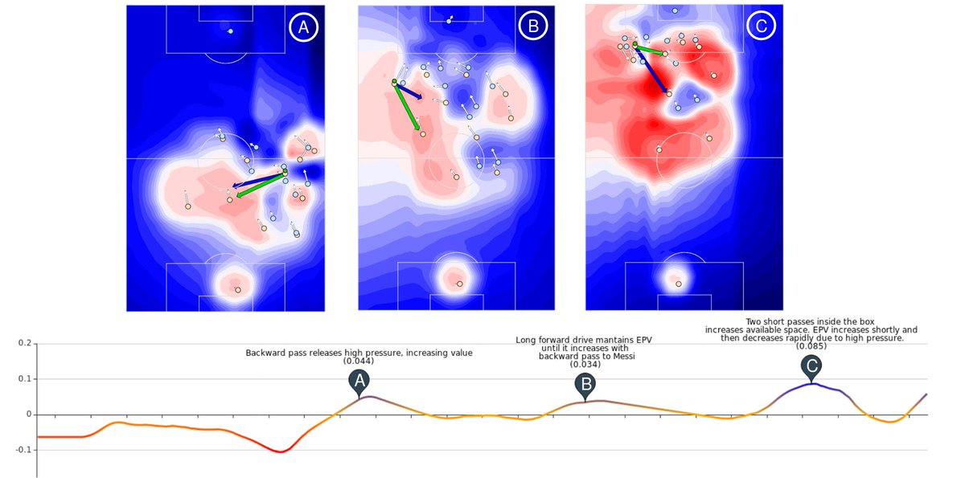

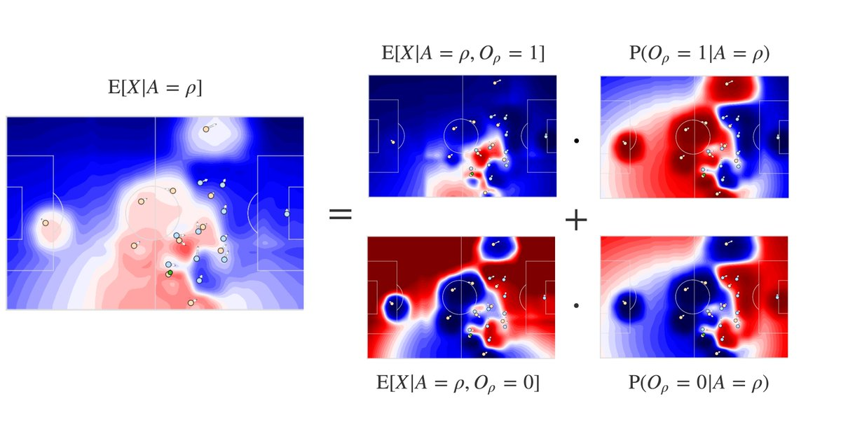

EPV (expected possession value) provides a frame-by-frame evaluation of the expected outcome of a possession, based on a wide set of both spatial and contextual features. Basically, we get closer to evaluate the impact of every decision (hint: passing back does help sometimes)

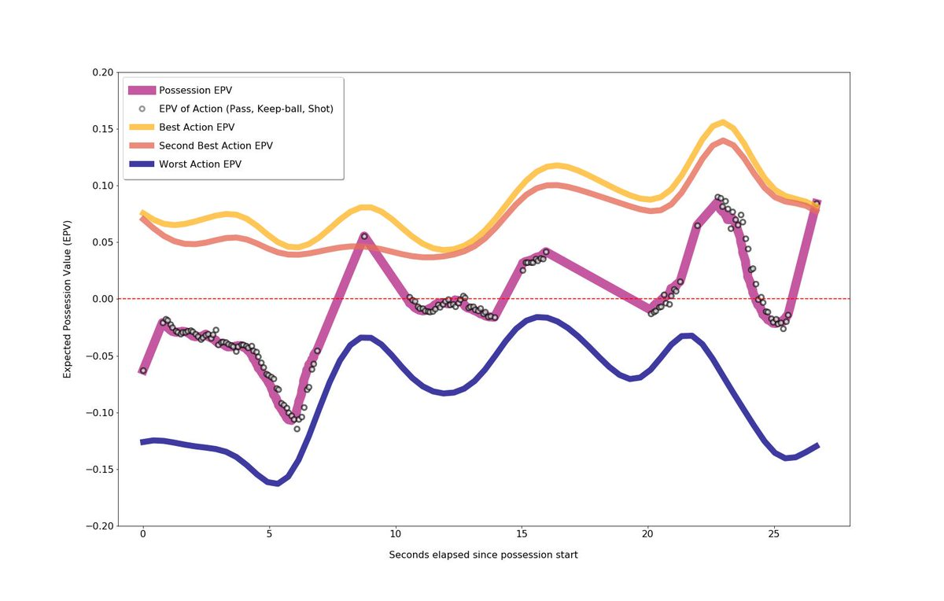

Instead of solving a specific soccer questions, this time we provide a tool for solving many other questions by taking into account the risk of turnover, action reward, space control, changing positioning dynamics... The idea: to improve the qualitative aspect of game analysis.

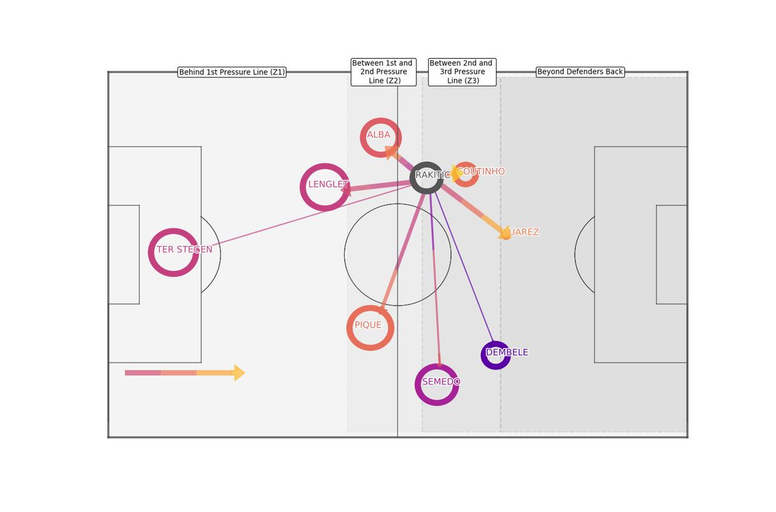

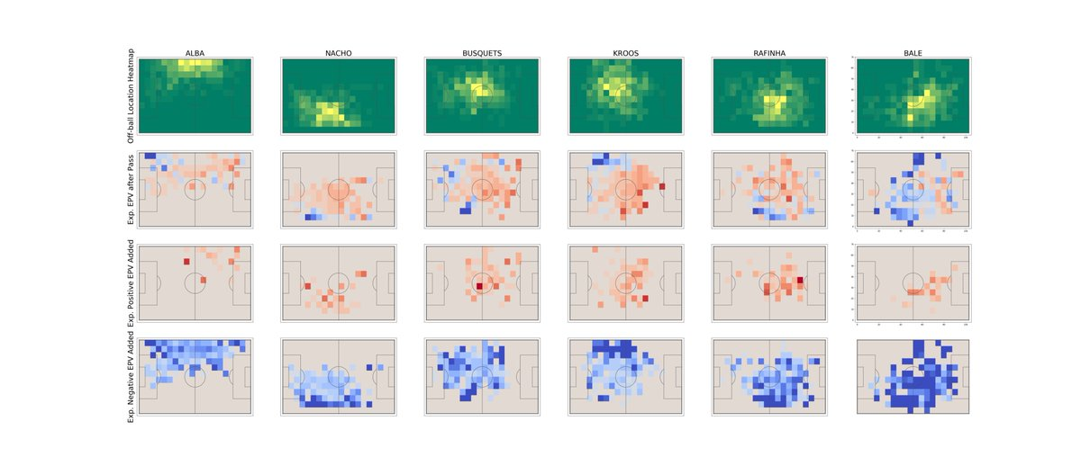

Personally it was a great opportunity to work on top of my favorite research paper in sports analytics, the original introduction of EPV for basketball by [~~@~~**alexdamour**](https://twitter.com/alexdamour) [~~@~~**dcervone0**](https://twitter.com/dcervone0) [~~@~~**LukeBornn**](https://twitter.com/LukeBornn) and [~~@~~**kirkgoldsberry**](https://twitter.com/kirkgoldsberry) ([http://www.sloansportsconference.com/wp-content/uploads/2018/09/cervone_ssac_2014.pdf …](https://t.co/Z5CJh7xVxP), [https://arxiv.org/pdf/1408.0777.pdf …](https://t.co/m2JHWZYd57))

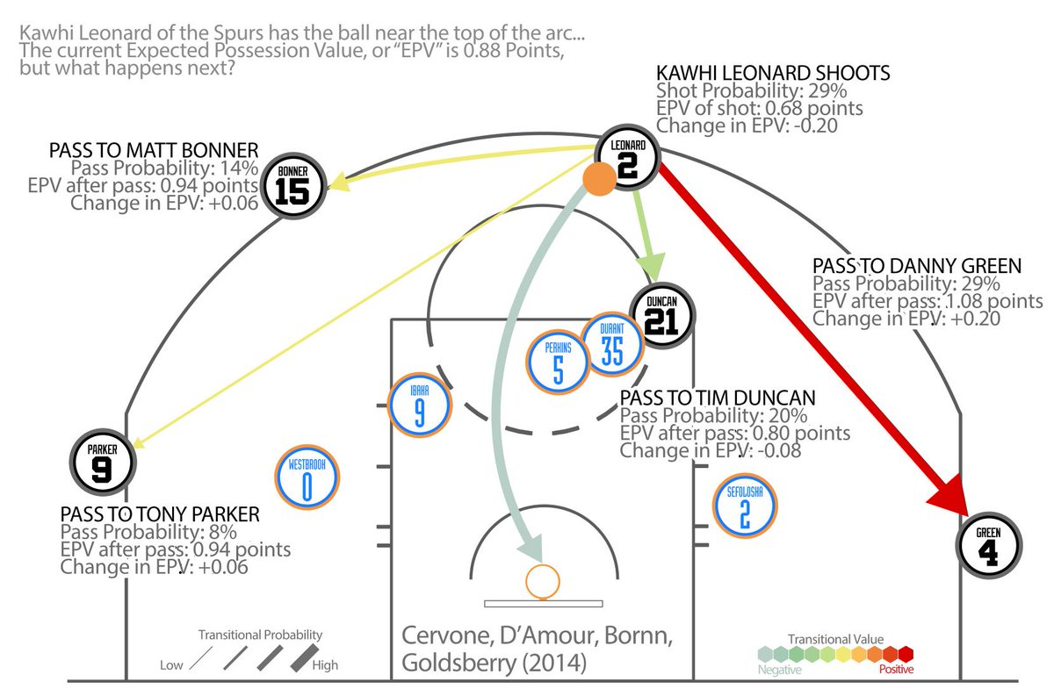

dfsdf

In the paper we make a strong effort to talk as much about soccer as possible. Challenges in this game are different from other sports. However, you can learn a lot from these, and who better than two multi-sport analysis giants like [~~@~~**dcervone0**](https://twitter.com/dcervone0) [~~@~~**LukeBornn**](https://twitter.com/LukeBornn) to start that path.